**VEHICLE SERVICE AND WASH WEBSITE**

**A PROJECT REPORT**

**For**

**Major Project (KCA 451)**

**Session (2023 - 24)**

**Submitted By**

**TUSHAR KUMAR**

**(2200290140164)**

**Submitted in partial fulfillment of the**

**Requirements for the Degree of**

**MASTER OF COMPUTER APPLICATION**

**Under the Supervision of**

### **Dr. Akash Rajak**

### **PROFESSOR**



**Submitted to**

**Department Of Computer Applications**

**KIET Group of Institutions, Ghaziabad**

**Uttar Pradesh-201206**

**(MAY 2024)**

**CERTIFICATE**

Certified that **Tushar Kumar 2200290140164**  has/ have carried out the project work having “**Vehicle Service And Wash Website**” for **Master of Computer Application** from Dr. A.P.J. Abdul Kalam Technical University (AKTU**)** (formerly UPTU), Lucknow under my supervision. The project report embodies original work, and studies are carried out by the student himself/herself and the contents of the project report do not form the basis for the award of any other degree to the candidate or to anybody else from this or any other University/Institution.

**Date:**

**Tushar Kumar(2200290140164)**

This is to certify that the above statement made by the candidate is correct to the best of my knowledge.

Date:

**Dr. Akash Rajak Dr. Arun Kumar Tripathi**

**Professor Professor & Head**

**Department of Computer Applications Department of Computer Applications**

**KIET Group of Institutions, Ghaziabad KIET Group of Institutions, Ghaziabad**

**ABSTRACT**

Automotive service is a comprehensive online platform designed to revolutionize the vehicle service and wash industry by offering a seamless and efficient experience for both customers and service providers. In today's fast-paced world, owning a vehicle entails not just convenience but also the responsibility of its regular maintenance and cleanliness. Automotive service aims to address these needs by providing a one-stop solution accessible through web and mobile interfaces.

Key features of Automotive service include an intuitive user interface that allows customers to schedule service appointments and car washes with just a few clicks. Through the platform, users can browse a network of trusted service centers and car wash facilities, select desired services, and choose convenient appointment times. The system incorporates advanced algorithms to match users with nearby service providers based on their preferences and availability, ensuring prompt and hassle-free scheduling.

For service providers, Automotive service offers a robust dashboard to manage appointments, track service histories, and communicate with customers in real-time. The platform optimizes resource allocation and streamlines operations, enhancing efficiency and reducing administrative overhead. Additionally, Automotive service facilitates customer engagement through personalized service recommendations, loyalty programs, and feedback mechanisms, fostering long-term relationships and loyalty.

With its focus on convenience, reliability, and transparency, Automotive service aims to redefine the vehicle service and wash experience, empowering customers to maintain their vehicles effortlessly while enabling service providers to optimize their operations and grow their businesses. By leveraging technology to bridge the gap between customers and service providers, Automotive service seeks to elevate industry standards and set a new benchmark for excellence in vehicle care.

**ACKNOWLEDGEMENTS**

Success in life is never attained single handedly. My deepest gratitude goes to my thesis supervisor, **Dr**. **Akash Rajak** for her guidance, help and encouragement throughout my research work. Their enlightening ideas, comments, and suggestions.

Words are not enough to express my gratitude to **Dr**. **Arun Kumar Tripathi**, Professor and Head, Department of Computer Applications, for his insightful comments and administrative help at various occasions.

Fortunately, I have many understanding friends, who have helped me a lot on many critical conditions.

Finally, my sincere thanks go to my family members and all those who have directly and indirectly provided me moral support and other kind of help. Without their support, completion of this work would not have been possible in time. They keep my life filled with enjoyment and happiness.

**TUSHAR KUMAR**

**TABLE OF CONTENTS**

|  |  |  |  |
| --- | --- | --- | --- |
|  | Certificate | | ii |
|  | Abstract | | ii |
|  | Acknowledgement | | iii |
|  | Table of Contents | | iv |
|  | List of Tables | | vi |
|  | List of Figures | | vii |
|  |  | |  |
| 1 | Introduction | | 1-5 |
|  | 1.1 | Overview | 1 |
|  | 1.2 | Objective | 1 |
|  | 1.3 | Key Features | 2-3 |
|  |  | 1.3.1. User Registration and Authentication | 2 |
|  |  | 1.3.2. Service Appointment Scheduling | 2 |
|  |  | 1.3.2. Car Wash Booking | 2 |
|  | 1.4 | Hardware/Software used in Project | 3-5 |
| 2 | Feasibility Study | | 6-9 |
|  | 2.1 | Key Objectives | 6 |
|  | 2.2 | Technical Feasibility | 6-7 |
|  | 2.3 | Operational Feasibility | 7 |
|  | 2.4 | Behavioral Feasibility | 7 |
|  | 2.5 | Schedule Feasibility | 8-9 |
| 3 | Design | | 12-21 |
|  | 3.1 | Database Tables | 12-13 |
|  | 3.2 | Flowchart | 14 |
|  | 3.3 | Use Case Diagram | 14-16 |
|  | 3.4 | Data Flow Diagram | 16-21 |
|  | 3.5 | ER-Diagram | 11 |
|  | 3.6 | Activity Diagram | 11 |
| 4 | Project Process |  | 22-30 |
| 5 | Testing |  | 31-32 |
|  |  | 5.1 Key Objectives | 31 |
|  |  | 5.2 Testing Methodologies | 32 |
|  |  | 5.3 Collaborative Testing | 32 |
|  | Bibliography | | 33 |
|  | References | | 34 |

**LIST OF TABLES**

|  |  |  |
| --- | --- | --- |
| **Table No.** | **Name of Table** | **Page** |
| 3.1 | Login Table | 15 |
| 3.2 | Register Table | 16 |
| 3.3 | Periodic Service Table | 16 |
| 3.4 | AC Service Table | 17 |
| 3.5 | Denting And Penting Table | 17 |
|  |  |  |
|  |  |  |
|  |  |  |
|  |  |  |

**LIST OF FIGURES**

|  |  |  |  |
| --- | --- | --- | --- |
| **Figure No.** | **Name of Figure** | **Page No.** | |
| 1.1 | Home Page | | 2 | |
| 1.2 | About Us | | 3 | |
| 2.1 | Schedule Feasibility (Gantt Chart) | | 14 | |
| 3.1 | Flowchart Diagram | | 19 | |
| 3.2 | Use Case Diagram | | 20 | |
| 3.3 | Level 0 DFD | | 21 | |
| 3.4 | Level 1 DFD | | 22 | |
| 3.5 | Level 2 DFD | | 23 | |
| 3.6 | ER Diagram | | 24 | |
| 3.7 | Activity Diagram | | 25 | |
| 4.1 | Sign Up Page | | 26 | |
| 4.2 | Login Page | | 27 | |
| 4.3 | Service Page | | 28 | |
| 4.4 | Service Page | | 28 | |
| 4.5 | Periodic Service Page | | 29 | |
| 4.6 | Periodic Service Page | | 29 | |
| 4.7 | Periodic Service Page | | 30 | |
| 4.8 | Periodic Service Page | | 30 | |
| 4.9 | AC Service Page | | 31 | |
| 4.10 | AC Service Page | | 31 | |
| 4.11 | AC Service Page | | 32 | |
| 4.12 | AC Service Page | | 32 | |
| 4.13 | Car Wash & Cleaning Page | | 33 | |
| 4.14 | Car Wash & Cleaning Page | | 33 | |
| 4.15 | Car Wash & Cleaning Page | | 34 | |
| 4.16 | Denting and Penting Page | | 34 | |
| 4.17 | Denting and Penting Page | | 35 | |
| 4.18 | Denting and Penting Page | | 35 | |
| 4.19 | Denting and Penting Page | | 36 | |
| 4.20 | Denting and Penting Page | | 36 | |
| 4.21 | Denting and Penting Page | | 37 | |
| 4.22 | Denting and Penting Page | | 37 | |
| 4.23 | Denting and Penting Page | | 38 | |

**CHAPTER 1**

**INTRODUCTION**

Automotive service aims to develop a comprehensive online platform for vehicle service and wash, addressing the growing need for convenient, efficient, and reliable vehicle maintenance solutions. In today's fast-paced world, vehicle owners often struggle to find time for regular service and cleaning. This project seeks to bridge this gap by providing a user-friendly website that connects customers with trusted service providers, streamlining the entire process from appointment scheduling to service delivery.

**1.1** **OVERVIEW**

## The Vehicle Service and Wash Website project aim to develop an online platform that facilitates the scheduling of vehicle service appointments and car washes. The platform connects customers with service providers, enabling seamless coordination and efficient management of vehicle maintenance tasks.

## **1.2 OBJECTIVES**

* Develop a user-friendly website interface accessible from both web and mobile devices.
* Implement features for customers to schedule service appointments and car washes conveniently.
* Create a database of trusted service centers and car wash facilities.
* Integrate algorithms for matching users with nearby service providers based on preferences and availability.
* Provide service providers with a robust dashboard for managing appointments, tracking service histories, and communicating with customers.
* Incorporate features for personalized service recommendations, loyalty programs, and customer feedback.
* Ensure security and privacy of user data through encryption and secure authentication protocols. 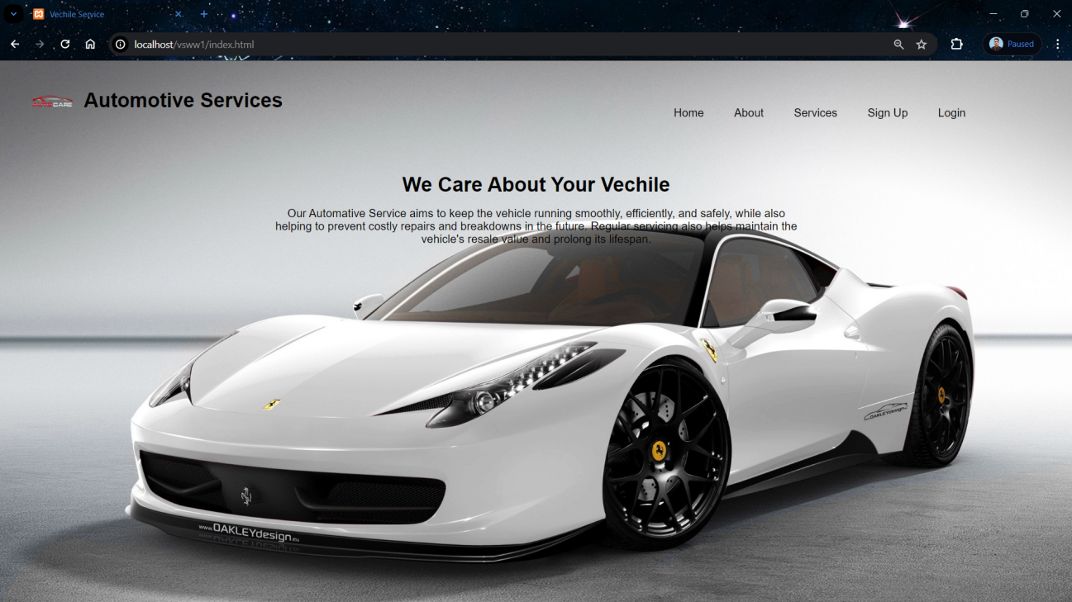

**Fig. 1.1 Home Page**

## **1.3 KEY FEATURES**

**1.3.1 User Registration and Authentication:**

* Users can create accounts and log in securely to access the platform's features.

**1.3.2 Service Appointment Scheduling:**

* Customers can schedule appointments for vehicle servicing, including oil changes, tire rotations, and inspections.

**1.3.3 Car Wash Booking:**

* Users can book car wash services, selecting from various wash packages and add-on options.

**1.3.4 Service Provider Directory:**

* The platform hosts a directory of trusted service centers and car wash facilities, providing users with a selection of options based on location and services offered.

**1.3.5 Real-time Availability and Booking:**

* Customers can view real-time availability for service appointments and car wash slots, allowing them to book convenient time slots instantly.

**1.3.6 Appointment Management Dashboard:**

* Service providers have access to a dashboard where they can manage appointments, track service histories, and communicate with customers.

**1.3.7 Service History Tracking:**

* The platform maintains a record of users' service histories, allowing them to track past appointments and services rendered.

**1.3.8 Customer Communication and Feedback:**

* Users can communicate with service providers, ask questions, and provide feedback on their service experience.

**1.3.9 Personalized Recommendations:**

* The platform offers personalized service recommendations based on users' vehicle make, model, and service history.

**1.3.10 Loyalty Programs and Rewards:**

* Customers can enroll in loyalty programs and earn rewards points for frequent service bookings.

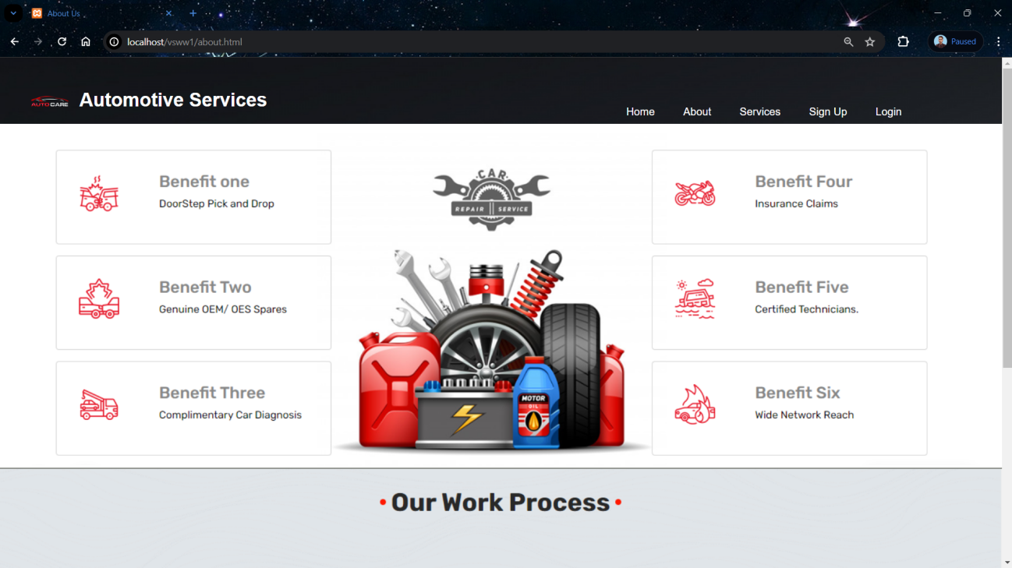

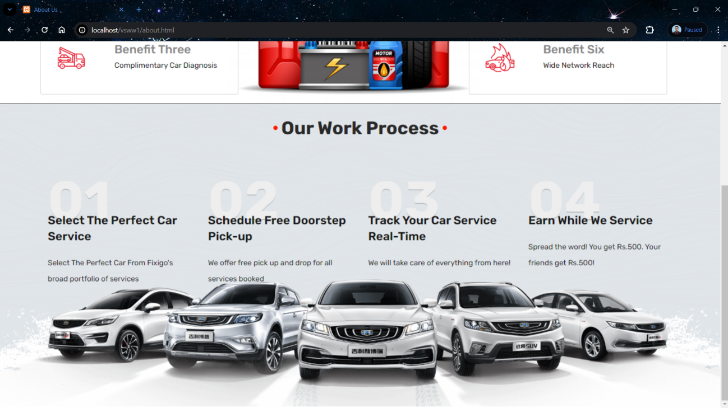 **Fig. 1.2 About Us**

## **1.4 HARDWARE / SOFTWARE USED IN PROJECT**

The Vehicle Service and Wash Website will involve a combination of hardware and software components to ensure its development, deployment and functionality. Here is detailed List:

**1.4.1 Server-side Hardware:**

**1. RAM (Random Access Memory):**

* 8GB to 16GB (for moderate-sized application and user load).
* Consider higher capacities (e.g., 32GB or more) for scalability and handling a large number of concurrent users.

**2. ROM (Storage):**

* SSD storage for faster read and write operations.
* Allocate storage based on the application co debase, database size, and media storage requirements.

**3. Processor:**

* Multi-core processor (quad-core or higher) for efficient handling of concurrent user requests.

**4. Operating System:**

* Windows based operating system.

**5. Network Equipment:**

* Network infrastructure to facilitate secure data transfer between users and the server.

**1.4.2 Database Server:**

**1. RAM:**

* 8GB or more for efficient handling of concurrent database queries.

**2. ROM(Storage):**

* SSD storage for faster data retrieval.
* Allocate storage based on the anticipated size of the database and data storage needs.

**3. Processor:**

* Multi-core processor with sufficient processing power for complex database operations.

**4. Operating System:**

* Windows operating system for the database server.

**1.4.3 User Devices:**

**1. Smartphones/Tablets:**

* Compatibility with iOS and Android operating systems.
* Optimization for various screen sizes and resolutions.

**2. Web Browsers:**

* Compatibility with major web browsers such as Google Chrome, Mozilla Firefox, Safari, and Microsoft Edge.

**1.4.4 Development Environment:**

**1. Programming Languages:**

* Backend: PHP language.
* Frontend: HTML, CSS, JavaScript.

**2. Framework:**

* Web application framework

**3. Database Management System:**

* Choose a suitable DBMS (e.g., MySQL, PostgreSQL, MongoDB) for efficient data storage and retrieval.

**4. APIs:**

* Develop APIs to enable communication between the frontend and backend components.

**5. Integrated Development Environment (IDE):**

* IDEs such as Visual Studio Code, PyCharm, or IntelliJ IDEA for coding and debugging.

**CHAPTER 2**

**FEASIBILITY STUDY**

The feasibility study assesses the viability and potential success of implementing a vehicle service and wash website project. It examines various aspects including technical feasibility, economic viability, operational feasibility, and legal considerations:

* 1. **KEY OBJECTIVES**
     1. **Technical Feasibility**:
* **Technology Stack:** Assess the availability and suitability of technologies required for website development, including frontend (HTML, CSS, JavaScript) and backend (PHP, MYSQL).
* **Scalability:** Determine if the chosen technology stack can handle potential increases in user traffic and data volume over time.Assess the compatibility with existing systems in the educational institution.
* **Integration:** Evaluate the feasibility of integrating third-party APIs for features such as maps integration (Google Maps API) and payment gateway (Stripe API).
* **Security:** Assess the feasibility of implementing robust security measures to protect user data and prevent unauthorized access.
  + 1. **Economic Feasibility**:
* **Cost Estimation:** Estimate the initial development costs including software licenses, hardware infrastructure, and personnel expenses.
* **Revenue Model:** Analyze potential revenue streams such as service booking fees, premium service subscriptions, and advertising revenue.
* **Return on Investment (ROI):** Calculate the expected ROI based on projected revenue and investment costs over a specified time period.
* **Market Analysis:** Conduct market research to assess the demand for vehicle service and wash websites and identify potential competitors.
  + 1. **Legal Feasibility**:
* Ensure compliance with data protection laws such as GDPR (General Data Protection Regulation) and CCPA (California Consumer Privacy Act).
* Intellectual Property: Assess the risk of infringing on existing patents or trademarks and ensure that all intellectual property rights are respected.
* Contractual Agreements: Establish clear contractual agreements with service providers regarding terms of service, payment terms, and liability.
  + 1. **Operational Feasibility**:
* **User Acceptance:** Assess the likelihood of user acceptance and adoption of the website based on usability testing and feedback.
* **Resource Availability:** Determine if the necessary resources, including skilled personnel and infrastructure, are available to support the operation of the website.
* **Service Provider Engagement:** Evaluate the feasibility of engaging service providers and convincing them to join the platform.
* **Regulatory Compliance:** Ensure compliance with relevant regulations and legal requirements related to data protection, consumer rights, and online transactions.
  + 1. **Scheduling Feasibility**:
* Scheduling a project involves breaking down the tasks and assigning specific timelines for each to ensure the project progresses smoothly.

**2.2 Technical Feasibility**

* Examine the technical requirements of the proposed system.
* Evaluate the availability of technology and infrastructure needed for implementation.
* Assess the compatibility with existing systems in the educational institution.

**2.2.1 Infrastructure Requirements:**

* **Server Infrastructure:** Asses the capacity and scalability of cloud-based servers (e.g., AWS, Azure) to accommodate potential user growth and ensure seamless performance.
* **Database Management**: Evaluate the suitability of database systems (e.g., MySQL, PostgreSQL) for efficient storage and retrieval of user data.

**2.2.2 Software Development:**

* **Programming Languages:** Choose appropriate backend (e.g., PHP) and frontend (e.g., HTML, CSS, JAVASCRIPT) technologies based on developer expertise and project requirements.
* **Framework Selection**: Select a web application framework (e.g., Django, Flask) to streamline development and enhance maintainability.

**2.3 Operational Feasibility**

Operational feasibility is one of the key aspects to consider when evaluating the viability of a project, such as the Vehicle Service and Wash Website. This feasibility study assesses whether the proposed system can be implemented successfully within the existing organizational structure, processes, and technology.

**2.4 Behavioral Feasibility**

Behavioral feasibility assesses the project's acceptance and adoption by users, stakeholders, and employees. It focuses on understanding how people's behavior, attitudes, and perceptions may influence the success of the project.

**2.4.1 User Acceptance:**

* Conduct surveys, interviews, or focus groups to understand potential users' preferences, needs, and expectations regarding vehicle service and wash websites.
* Assess users' willingness to adopt online platforms for scheduling service appointments and car washes.
* Identify any barriers to user acceptance, such as concerns about privacy, security, or the reliability of online service providers.

**2.4.2 Stakeholder Engagement:**

* Engage with key stakeholders, including service providers, vehicle owners, and regulatory bodies, to gain their support and involvement in the project.
* Address any concerns or objections raised by stakeholders through open communication and collaboration.
* Demonstrate the benefits of the website project to stakeholders, highlighting how it can improve efficiency, convenience, and customer satisfaction.

**2.4.3 Change Management:**

* Evaluate the impact of the project on existing business processes and workflows within service centers and car wash facilities.
* Implement change management strategies to minimize resistance to change and facilitate the transition to the new system.
* Provide training and support to employees to ensure they are comfortable using the website and understand its benefits for both customers and service providers.

**2.4.4 User Experience Design:**

* Design the website interface with a focus on usability, simplicity, and intuitiveness to encourage user adoption.
* Conduct usability testing to identify any usability issues or pain points that may hinder user acceptance.
* Incorporate features such as clear navigation, intuitive booking flows, and responsive design to enhance the user experience across different devices and screen sizes.

**2.4.5 Communication and Marketing:**

* Develop a communication and marketing strategy to promote awareness and drive adoption of the website among target users.
* Utilize various channels, such as social media, email newsletters, and promotional campaigns, to reach potential users and stakeholders.
* Highlight the benefits and unique selling points of the website, such as convenience, reliability, and personalized service offerings, to attract users and differentiate the platform from competitors.

**2.4.6 Feedback Mechanisms:**

* Implement feedback mechanisms, such as customer surveys, ratings, and reviews, to gather feedback and insights from users.
* Actively listen to user feedback and incorporate suggestions for improvement into the website's features and functionalities.
* Demonstrate responsiveness to user feedback by addressing issues promptly and continuously iterating on the website to enhance the user experience.

**2.5 Schedule Feasibility**

Schedule feasibility assesses whether the project can be completed within the desired time frame, considering the available resources, dependencies, and potential risks. It involves estimating the time required for each phase of the project and identifying any constraints that may impact the project timeline.

**2.5.1 Project Planning:**

* Define the project scope, objectives, and deliverables in detail to establish a clear understanding of the project requirements.
* Develop a project schedule outlining key milestones, tasks, and deadlines for each phase of the project, including planning, development, testing, and deployment.

**2.5.2 Resource Allocation:**

* Identify the human, financial, and technological resources required to complete the project successfully.
* Allocate resources efficiently to ensure that the necessary expertise and support are available at each stage of the project.

**2.5.3. Task Estimation:**

* Break down the project tasks into smaller, manageable components to facilitate accurate estimation of time and effort.
* Use historical data, expert judgment, and project management techniques such as PERT (Program Evaluation and Review Technique) to estimate task durations and dependencies.

**2.5.4 Critical Path Analysis:**

* Identify the critical path, which represents the sequence of tasks that must be completed on time to ensure the project's overall timeline is met.
* Conduct a thorough analysis of dependencies, constraints, and potential bottlenecks that may affect the critical path and project schedule.

**2.5.5 Risk Management:**

* Identify potential risks and uncertainties that may impact the project schedule, such as technical challenges, resource constraints, and external dependencies.
* Develop contingency plans and mitigation strategies to address identified risks and minimize their impact on the project timeline.

**2.5.6 Iterative Development:**

* Adopt an iterative development approach, such as Agile or Scrum, to enable continuous feedback and adaptation throughout the project lifecycle.
* Break the project into smaller iterations or sprints, with regular review and adjustment of the project schedule based on feedback and progress.

**2.5.7 Monitoring and Control:**

* Implement robust project management tools and techniques to monitor progress, track milestones, and identify deviations from the project schedule.
* Conduct regular project status meetings and progress reports to keep stakeholders informed and address any schedule-related issues proactively.

**2.5.8 Flexibility and Adaptation:**

* Maintain flexibility in the project schedule to accommodate changes, unforeseen challenges, and evolving requirements.
* Be prepared to adjust priorities, reallocate resources, or renegotiate timelines as needed to ensure project success while minimizing schedule risks.

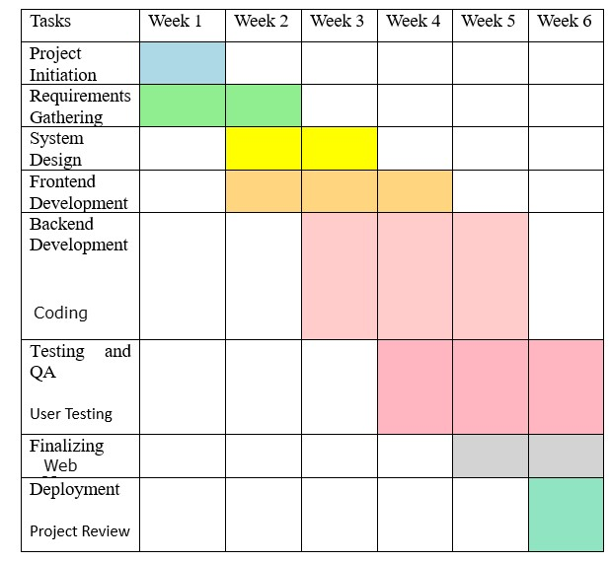

**Fig. 2.1 Schedule Feasibility (Gantt Chart)**

**CHAPTER 3**

**DATABASE DESIGN**

Designing the database for a Vehicle Service and Wash Website involves identifying the entities, their attributes, and the relationships between them. Below is a simplified example of how you might approach the database design for such a system:

* 1. **DATABASE TABLES**

Creating a comprehensive database table for the Vehicle Service and Wash Website involves considering the key entities and their attributes. Here's a basic representation:

**1** **Customers:**

* **Attributes:** CustomerID (Primary Key), Name, Email, Phone, Address

**2 Vehicles:**

* **Attributes:** VehicleID (Primary Key), CustomerID (Foreign Key), Fuel Type, Model, Year, License Plate Number

**3 Services:**

**Attributes:** ServiceID (Primary Key), ServiceName, Description, Price

**4 Appointments:**

**Attributes:** AppointmentID (Primary Key), CustomerID (Foreign Key), VehicleID (Foreign Key), ServiceID (Foreign Key), AppointmentDateTime, Status

**Now, let's identify the relationships between these entities:**

* Each customer can have multiple vehicles, so there's a one-to-many relationship between Customers and Vehicles.
* Customers can book multiple appointments for various services, creating a one-to-many relationship between Customers and Appointments.
* Vehicles can be associated with multiple appointments, leading to a one-to-many relationship between Vehicles and Appointments.
* Each appointment can have only one service but can be booked by multiple customers, resulting in a many-to-one relationship between Services and Appointments.
  + 1. **Login Table:**
* **Username :** Username of the customer.
* **Password :** Password of the customer.

|  |  |
| --- | --- |
| **Username** | **Password** |
| Vikky123 | Vive12k |
| Mahi45 | Mahi@3 |
| Ajay65 | Aj@y4 |

**Tab. 3.1 Login Table**

* + 1. **Register Table:**
* **Name :** Name of the customer.
* **Username:** Username of the customer.
* **Password:** Password of the customer.
* **Email:** Email of the customer.
* **Mobile Number :** Mobile number of the customer.

|  |  |  |  |  |
| --- | --- | --- | --- | --- |
| **Name** | **Username** | **Password** | **Email** | **Mobile Number** |
| Mr. Vivek Kumar | Vikky123 | Vive12k | vivek@gmail.com | 5678945678 |
| Mrs. Mahi Tyagi | Mahi45 | Mahi@3 | mahi@gmail.com | 4512789636 |
| Mr. Ajay Sharma | Ajay65 | Aj@y4 | ajay@gmail.com | 7896458725 |

**Tab. 3.2 Register Table**

* + 1. **Periodic Service:**
* **Username :** Username of the customer.
* **Address :** Address of the customer.
* **Brand :** Brand of the car.
* **Model :** Model of the car.
* **Fuel Type:** Fuel type of the car.
* **Service Plan:** Service plan choose by the customer.

|  |  |  |  |  |  |
| --- | --- | --- | --- | --- | --- |
| **Username** | **Address** | **Brand** | **Model** | **Fuel Type** | **Service Plan** |
| Vikky123 | Delhi | Audi | A4 | Petrol | Basic Service |
| Mahi45 | Ghaziabad | Volvo | Volvo S90 | Petrol | Standard Service |
| Ajay65 | Muradnagar | Hyundai | Venue | Petrol | Comprehensive Service |

**Tab. 3.3 Periodic Service**

* + 1. **AC Service :**
* **Username :** Username of the customer.
* **Address :** Address of the customer.
* **Brand :** Brand of the car.
* **Model :** Model of the car.
* **Service Plan:** Service plan choose by the customer.

|  |  |  |  |  |
| --- | --- | --- | --- | --- |
| **Username** | **Address** | **Brand** | **Model** | **Service Plan** |
| Vikky123 | Delhi | Audi | A4 | Regular AC Service |
| Mahi45 | Ghaziabad | Volvo | Volvo S90 | High Performance AC Service |
| Ajay65 | Muradnagar | Hyundai | Venue | Radiator Flush & Clean |

**Tab. 3.4 AC Service**

* + 1. **Denting And Painting :**
* **Username :** Username of the customer.
* **Address :** Address of the customer.
* **Brand :** Brand of the car.
* **Model :** Model of the car.
* **Service Plan:** Service plan choose by the customer.

|  |  |  |  |  |
| --- | --- | --- | --- | --- |
| **Username** | **Address** | **Brand** | **Model** | **Service Plan** |
| Vikky123 | Delhi | Audi | A4 | Front Bumper Paint |
| Mahi45 | Ghaziabad | Volvo | Volvo S90 | Bonnet Paint |
| Ajay65 | Muradnagar | Hyundai | Venue | Rear Bumper Paint |

**Tab. 3.5 Denting And Painting**

* + 1. **Wash Service :**
* **Username :** Username of the customer.
* **Address :** Address of the customer.
* **Brand :** Brand of the car.
* **Model :** Model of the car.
* **Service Plan:** Service plan choose by the customer.

|  |  |  |  |  |
| --- | --- | --- | --- | --- |
| **Username** | **Address** | **Brand** | **Model** | **Service Plan** |
| Vikky123 | Delhi | Audi | A4 | 360 Deep Cleaning |
| Mahi45 | Ghaziabad | Volvo | Volvo S90 | Premium Top Wash |
| Ajay65 | Muradnagar | Hyundai | Venue | Car Wash & Wax |

**Tab. 3.5 Wash Service**

* 1. **FLOW CHART**

Creating a flowchart for a Vehicle Service and Wash Website involves breaking down the system into various processes and illustrating the flow of information or actions between them. Below is a simplified example of a flowchart for such a system.

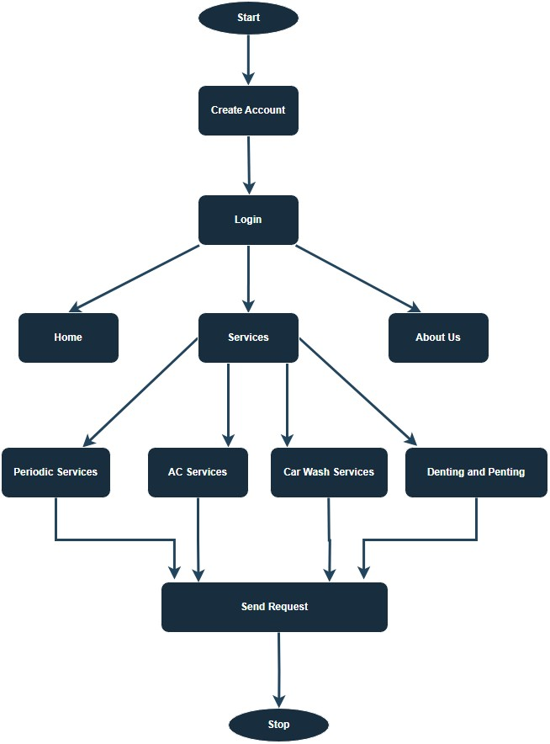

**Fig. 3.1 Flow chart Diagram**

* 1. **USE CASE DIAGRAM**

A Use Case Diagram is a visual representation in Unified Modeling Language (UML) that illustrates the interactions between different actors (users or external systems) and a system, showcasing various use cases and their relationships. In the context of a Vehicle Service and Wash Website project, the Use Case Diagram would outline the functionalities and interactions between different entities involved in the system.

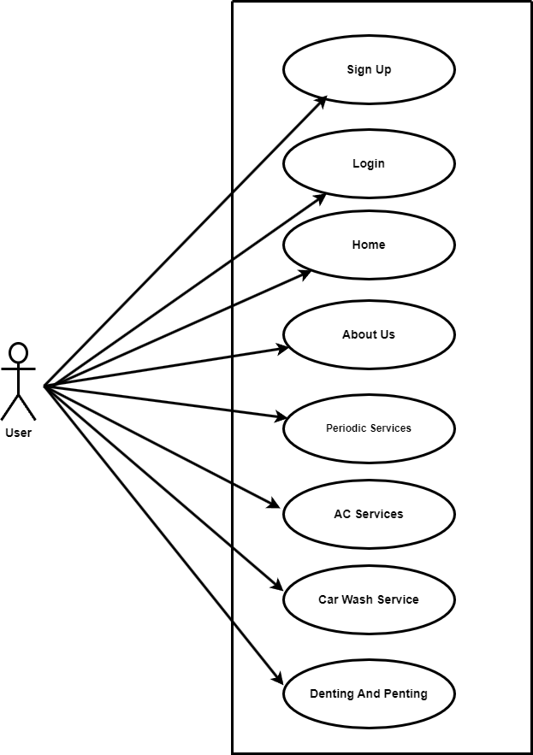

**Fig. 3.2 Use Case Diagram**

* 1. **DATA FLOW DIAGRAM**

**3.4.1 Vehicle Service And Wash Website DFD Level 0**

Level 0 is the highest-level Data Flow Diagram (DFD), which provides an overview of the entire system. It shows the major processes, data flows, and data stores in the system, without providing any details about the internal workings of these processes.

It is also known as a context diagram. It’s designed to be an abstraction view, showing the system as a single process with its relationship to external entities. It represents the entire system as a single bubble with input and output data indicated by incoming/outgoing arrows.

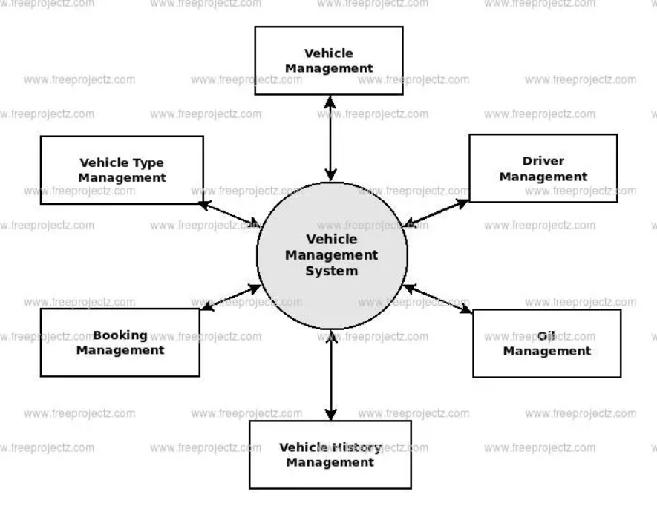

**Fig. 3.3 Level 0 DFD**

* User can create the account.
* User can login on the website.
* User can book the service.
* User can apply different level of filters on services like periodic service, ac service, car wash service, denting and penting.

**3.4.2 Vehicle Service And Wash Website DFD Level 1**

1-Level provides a more detailed view of the system by breaking down the major processes identified in the level 0 Data Flow Diagram (DFD) into sub-processes. Each sub-process is depicted as a separate process on the level 1 Data Flow Diagram (DFD). The data flows and data stores associated with each sub-process are also shown.

In 1-level Data Flow Diagram (DFD), the context diagram is decomposed into multiple bubbles/processes. In this level, we highlight the main functions of the system and breakdown the high-level process of 0-level Data Flow Diagram (DFD) into subprocesses.

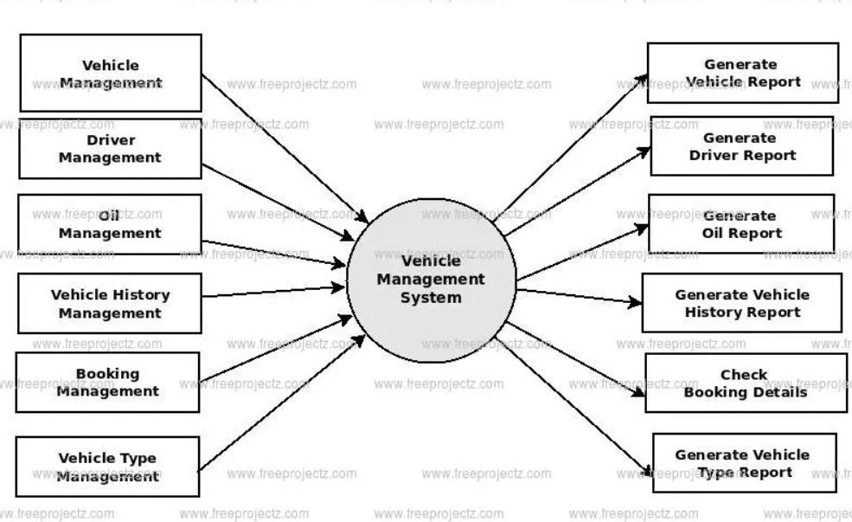

**Fig. 3.4 Level 1 DFD**

* User can create the account.
* User can login on the website.
* User can book the service.
* User can apply different level of filters on services like periodic service, ac service, car wash service, denting and penting.

**3.4.3** **Vehicle Service And Wash Website DFD Level 2**

2-Level provides an even more detailed view of the system by breaking down the sub-processes identified in the level 1 Data Flow Diagram (DFD) into further sub-processes. Each sub-process is depicted as a separate process on the level 2 DFD. The data flows and data stores associated with each sub-process are also shown.

2-Level Data Flow Diagram (DFD) goes one step deeper into parts of 1-level DFD. It can be used to plan or record the specific/necessary detail about the system’s functioning.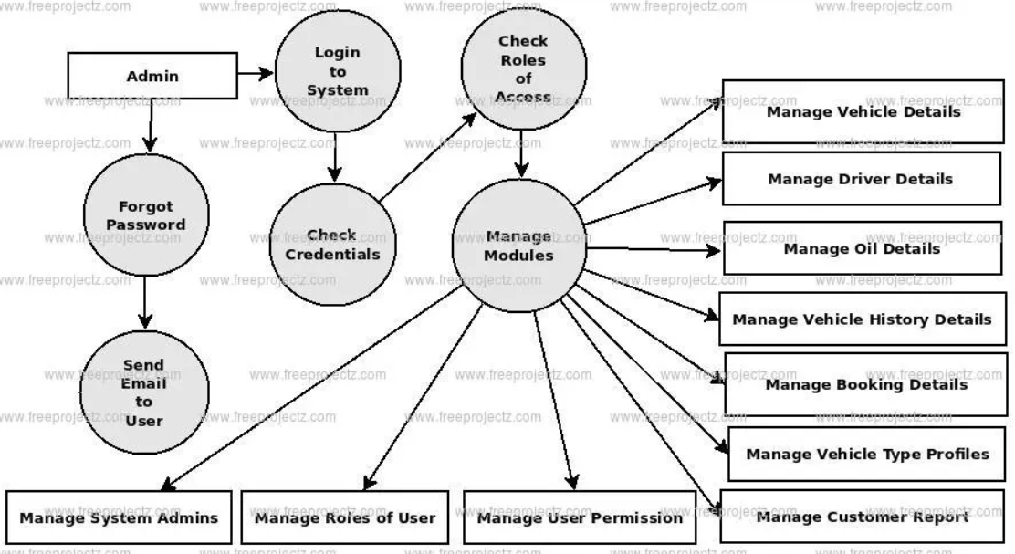

**Fig. 3.5 Level 2 DFD**

* User can create the account.
* User can login on the website.
* User can book the service.
* User can apply different level of filters on services like periodic service, ac service, car wash service, denting and penting.
  1. **ER-DIAGRAM**

Certainly! An Entity-Relationship (ER) diagram models the relationships between entities in a system. Here's a basic ER diagram for a Vehicle Service and Wash Website:

**Entities:**

1. User
2. Service
3. Periodic Service
4. AC Service
5. Car Wash Service
6. Denting And Penting

**Relationships:**

* Each customer can have multiple vehicles, so there's a one-to-many relationship between Customers and Vehicles.
* Customers can book multiple appointments for various services, creating a one-to-many relationship between Customers and Appointments.
* Vehicles can be associated with multiple appointments, leading to a one-to-many relationship between Vehicles and Appointments.
* Each appointment can have only one service but can be booked by multiple customers, resulting in a many-to-one relationship between Services and Appointments.

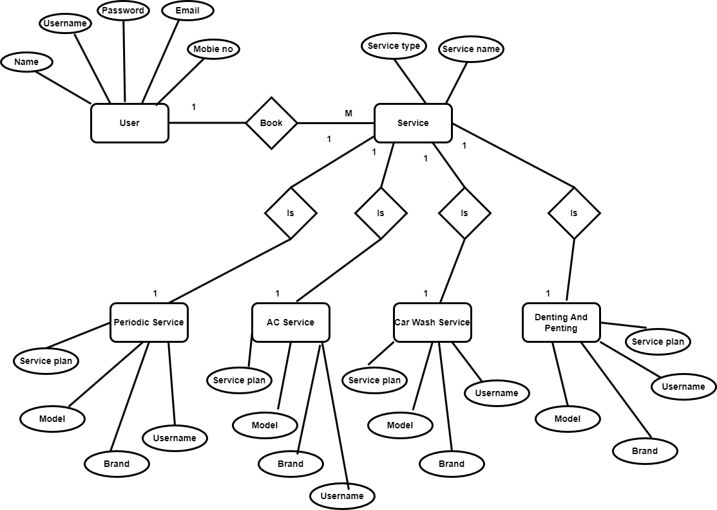

**Fig. 3.6 ER-Diagram**

* 1. **ACTIVITY DIAGRAM**

Activity diagrams are one of the behavioral diagrams defined in the Unified Modeling Language (UML), widely used in software engineering to visualize the flow of activities within a system or process. They provide a graphical representation of workflows, business processes, or software behaviors, depicting the sequence of actions, decisions, and control flows involved in achieving a particular goal.

Key components of an activity diagram include:

1. **Activities:** Represent specific tasks or actions that are performed as part of the process. These can range from simple actions like "Send Email" to more complex tasks like "Process Payment."
2. **Transitions:** Show the flow of control between activities, indicating the sequence in which activities are performed. Transitions are typically represented by arrows.
3. **Decisions:** Represent points in the process where a decision must be made. Depending on certain conditions or criteria, the process flow may diverge into multiple paths.
4. **Forks and Joins:** Forks split the flow of control into multiple concurrent paths, allowing activities to be executed in parallel. Joins merge multiple concurrent paths back into a single flow.
5. **Initial and Final Nodes:** Indicate the start and end points of the activity diagram, respectively.

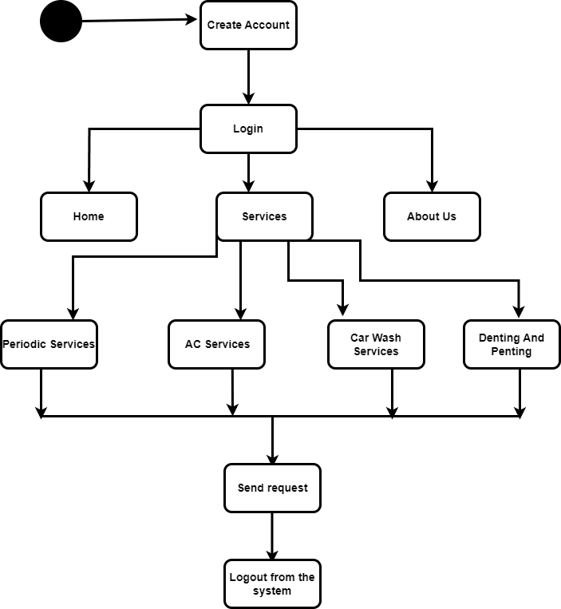

**Fig. 3.7 Activity Diagram**

**CHAPTER 4**

**PROJECT PROCESS**

The Faculty Contribution Management System is a mini project designed to streamline and enhance the management of academic contributions by faculty members in an educational institution. The system provides a centralized platform for faculty members to submit, track, and manage their contributions such as research papers, projects, publications, and other scholarly activities. It also offers administrative functionalities for authorized personnel to oversee and generate reports on faculty contributions.

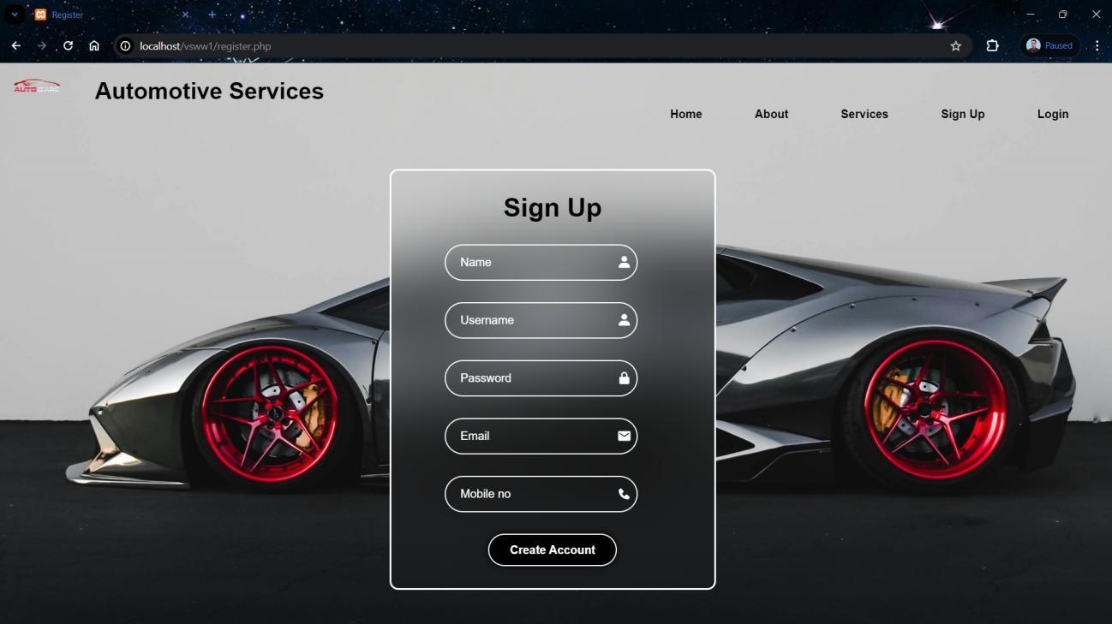

**Fig. 4.1 Sign Up Page**

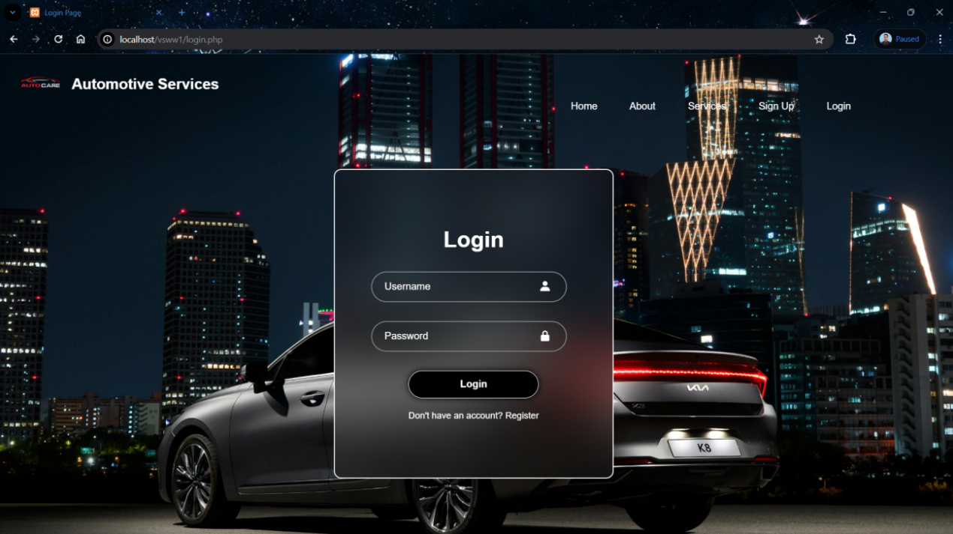

**Fig. 4.2 Login Page**

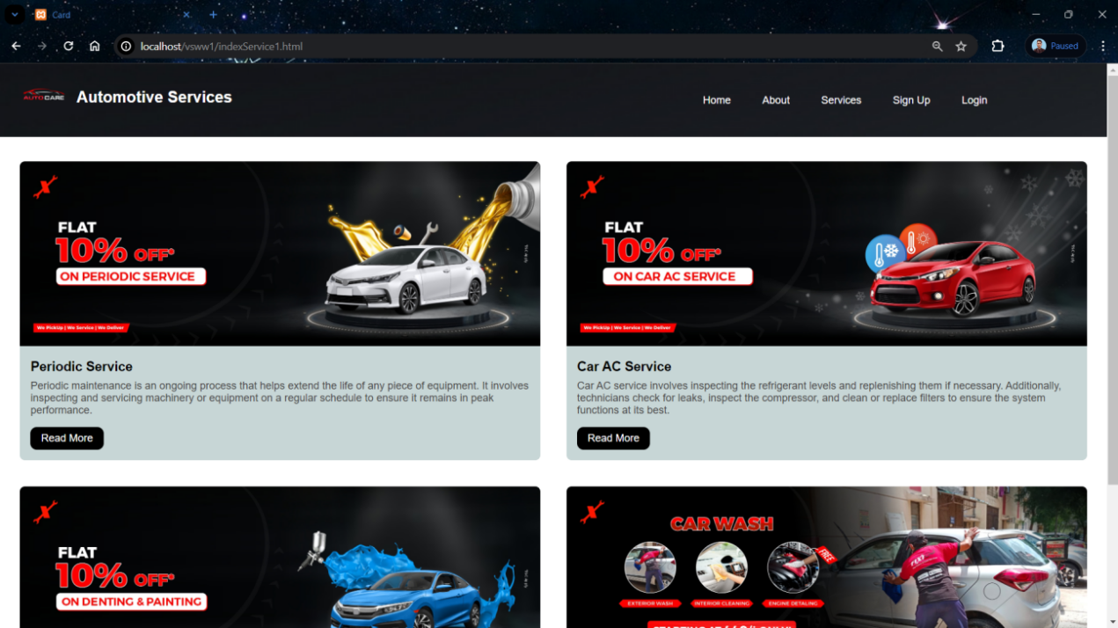

**Fig. 4.3 Service Page**

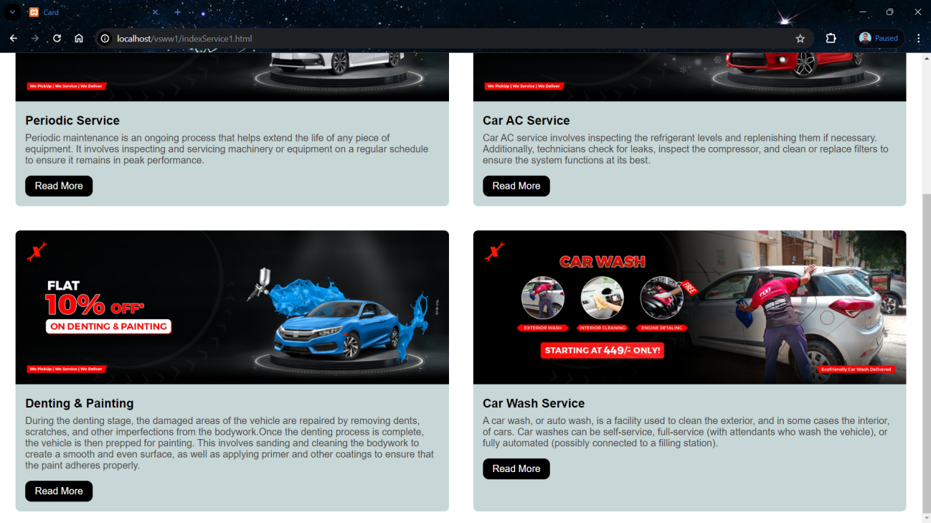

**Fig. 4.4 Service Page**

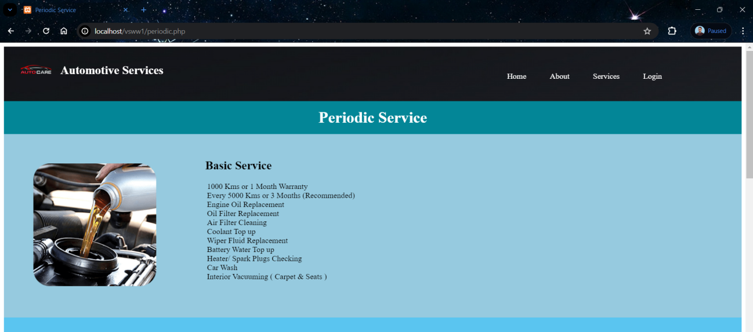

**Fig. 4.5 Periodic Service Page**

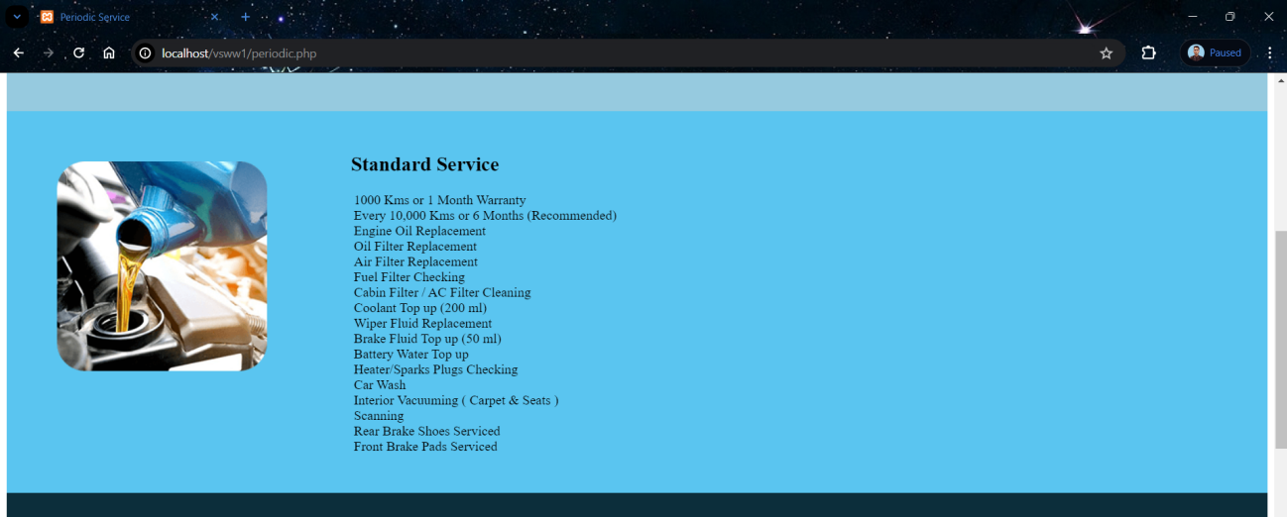

**Fig. 4.6 Periodic Service Page**

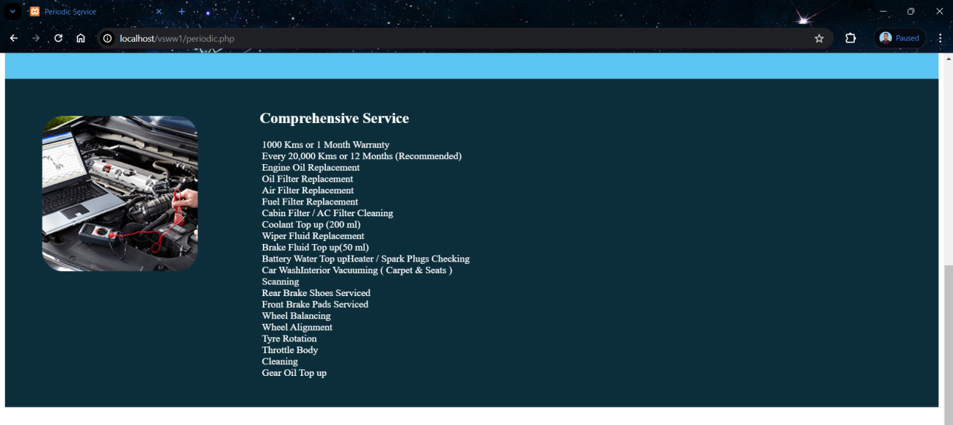

**Fig. 4.7 Periodic Service Page**

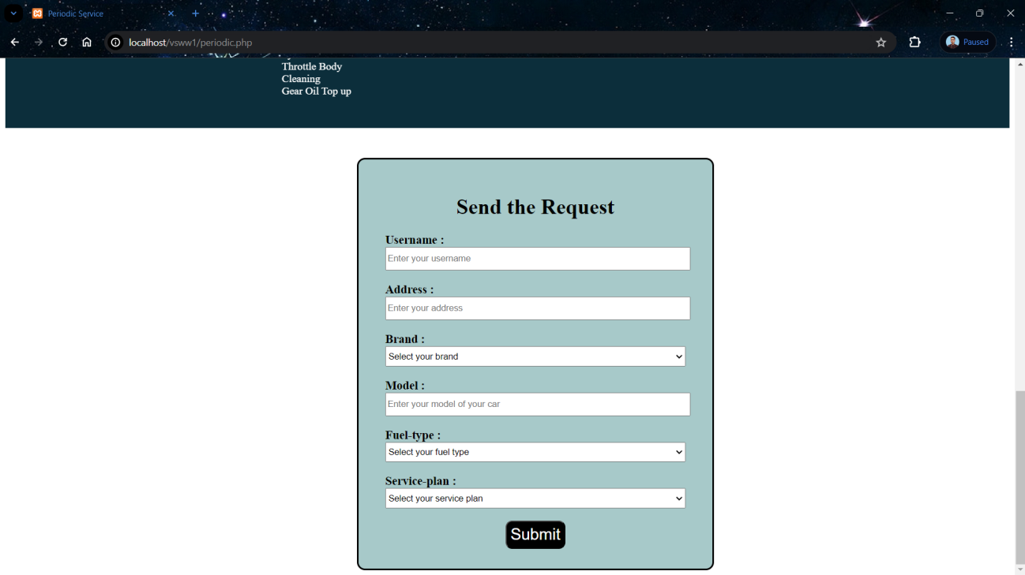

**Fig. 4.8 Periodic Service Page**

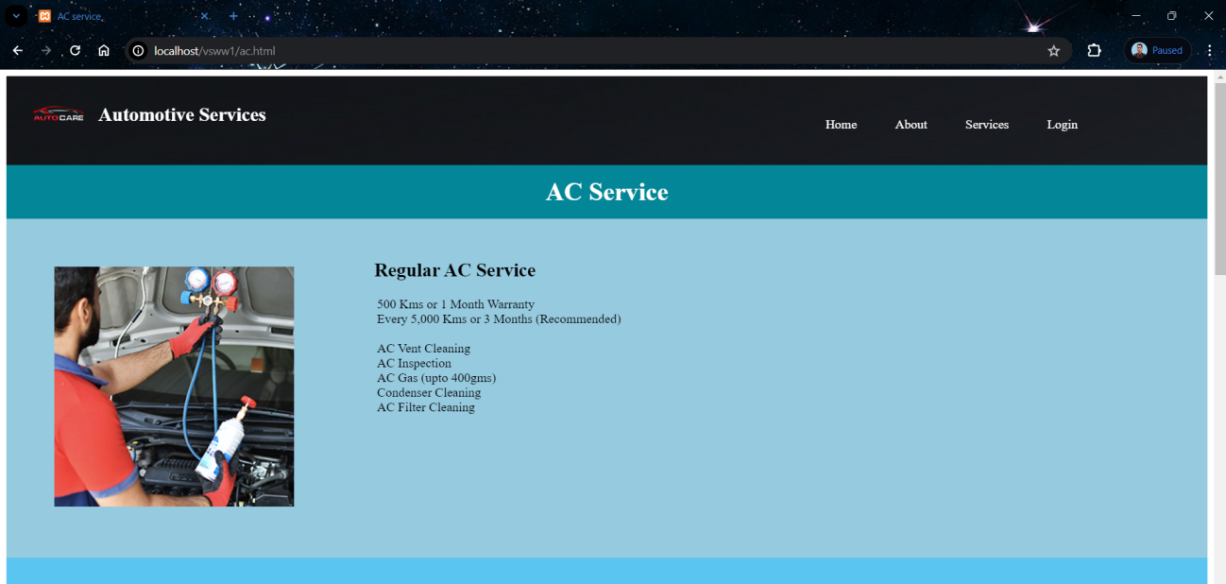

**Fig. 4.9 AC Service Page**

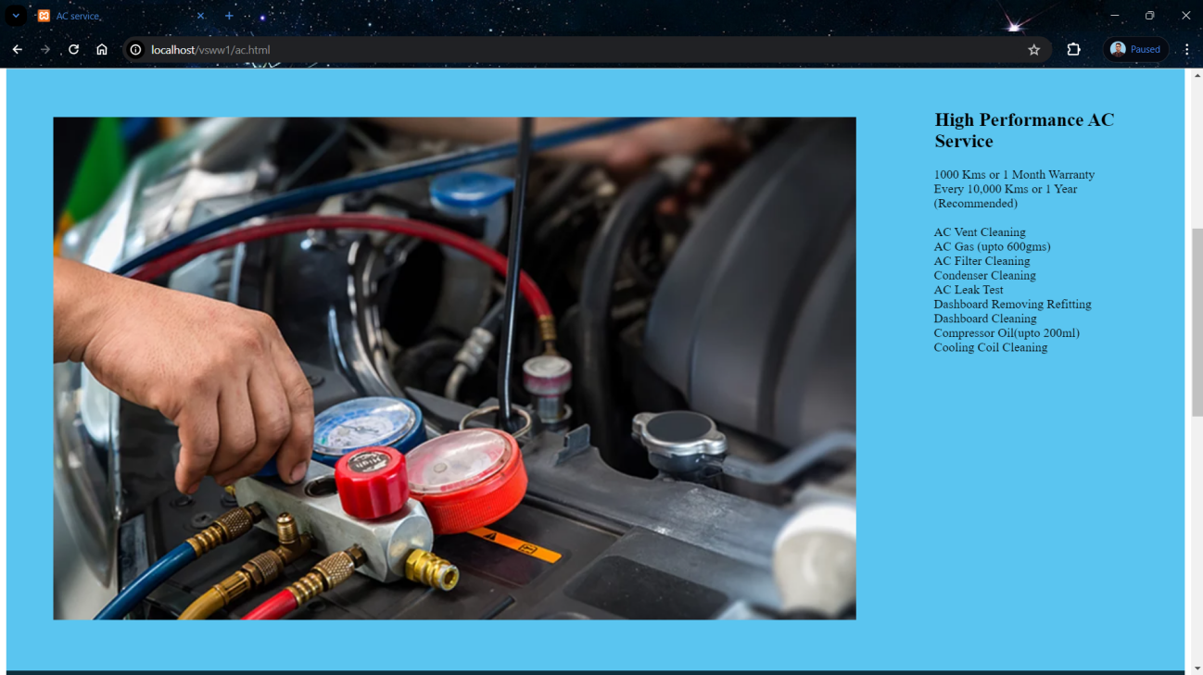

**Fig. 4.10 AC Service Page**

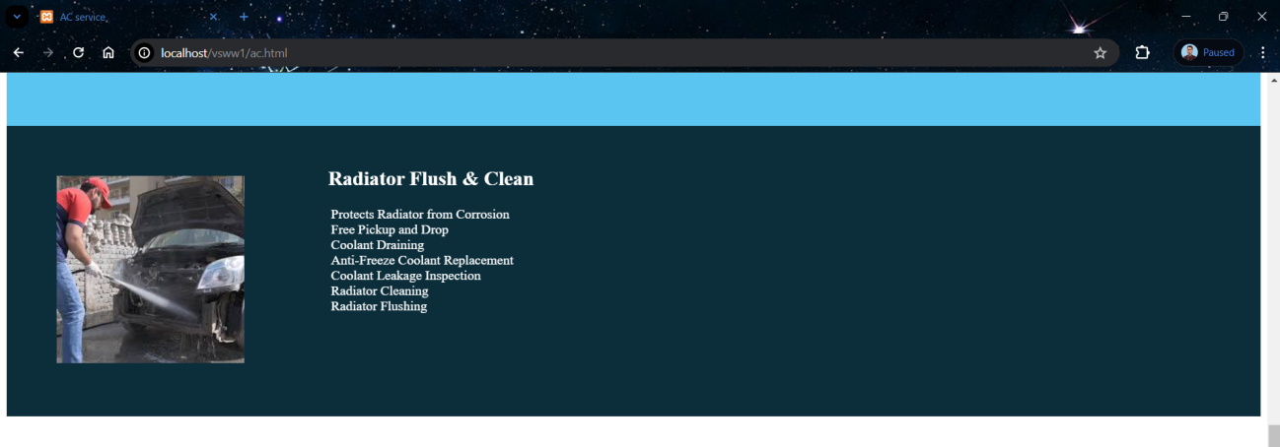

**Fig. 4.11 AC Service Page**

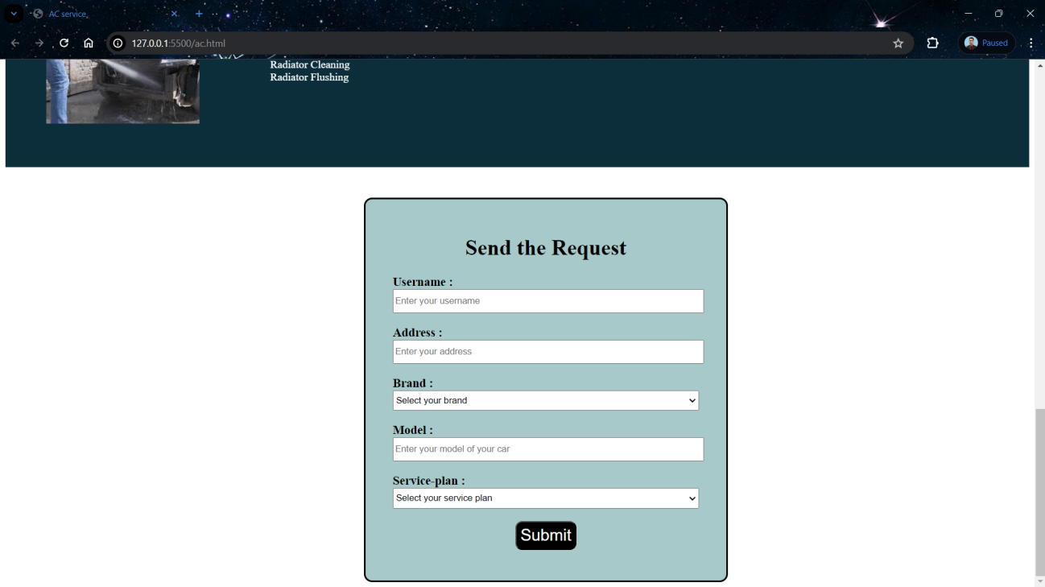

**Fig. 4.12 AC Service Page**

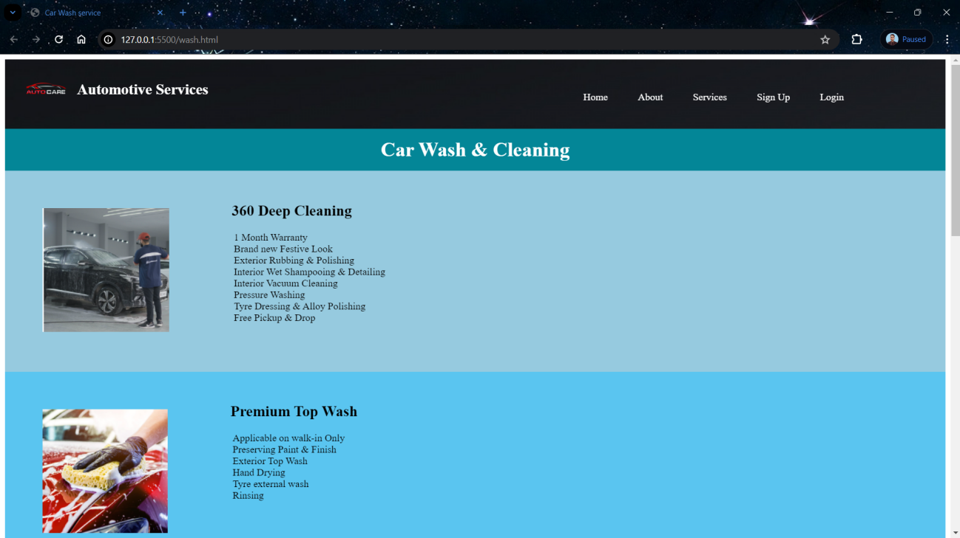

**Fig. 4.13 Car Wash & Cleaning Page**

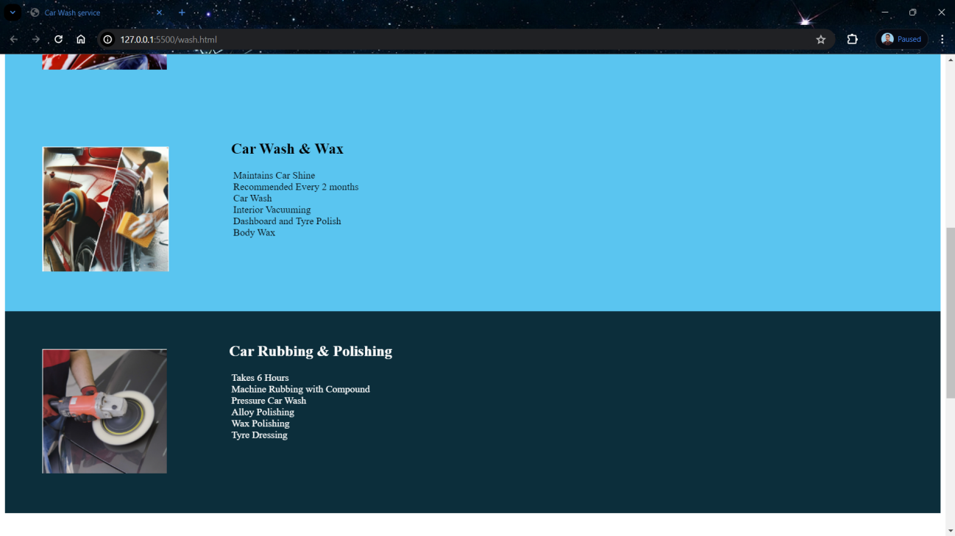

**Fig. 4.14 Car Wash & Cleaning Page**

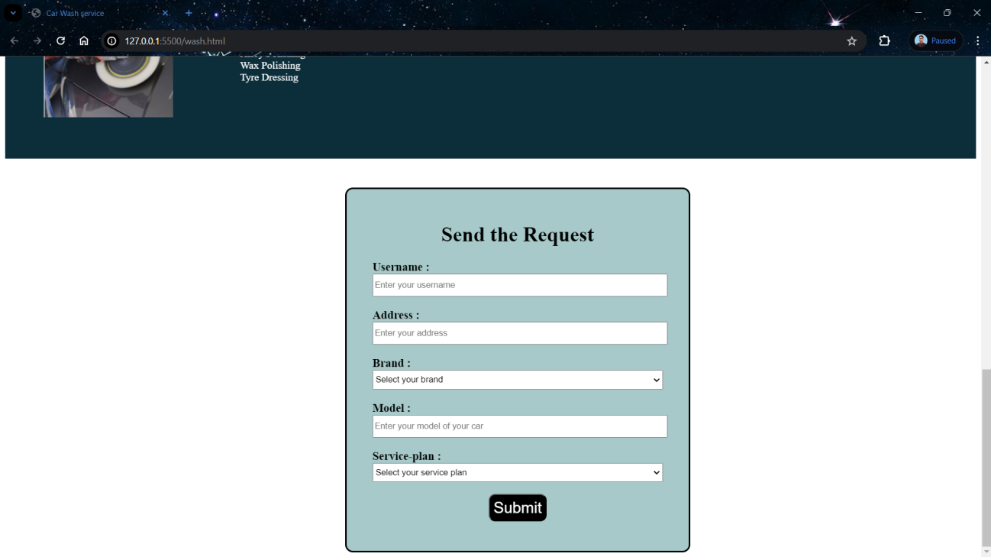

**Fig. 4.15 Car Wash & Cleaning Page**

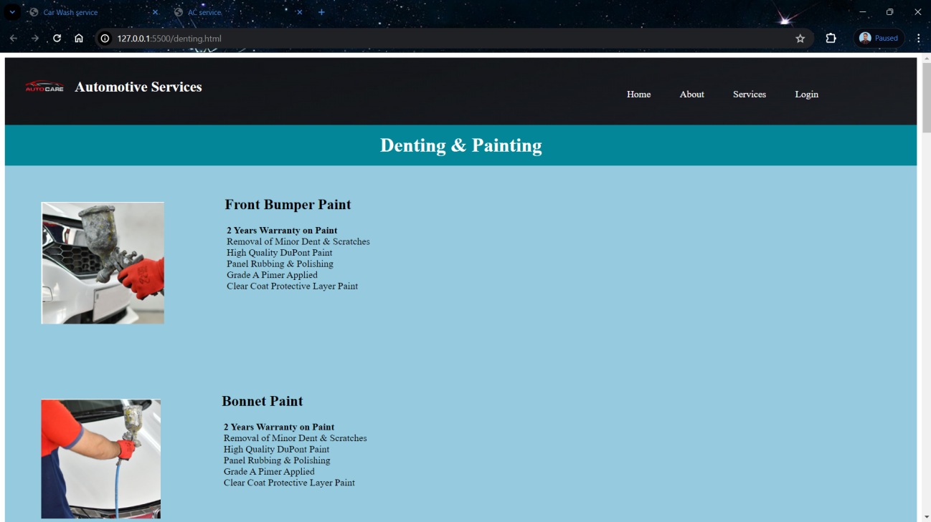

**Fig. 4.16 Denting And Penting Page**

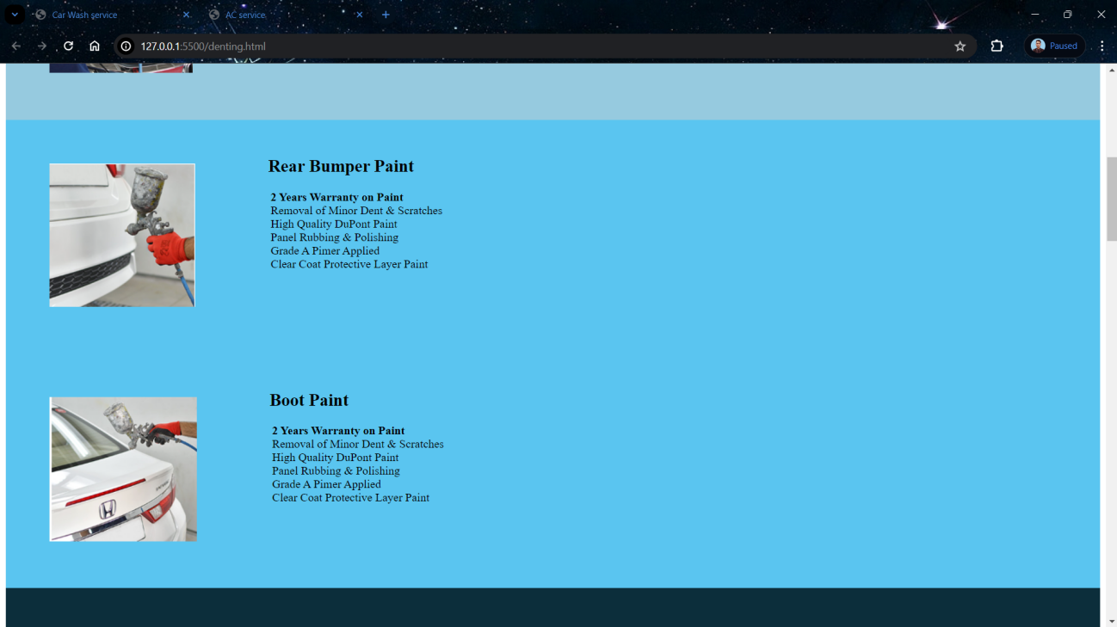

**Fig. 4.17 Denting And Penting Page**

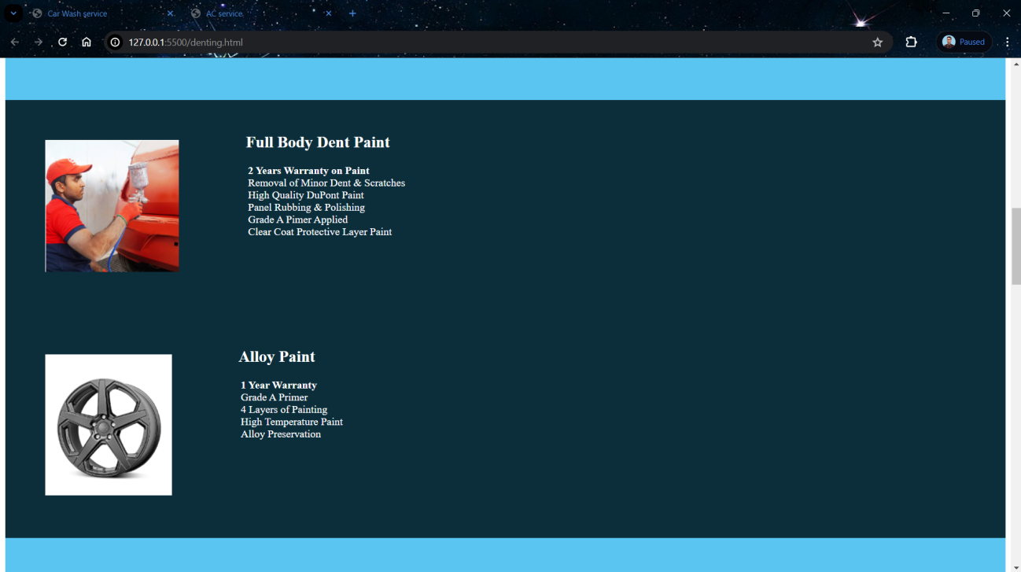

**Fig. 4.18 Denting And Penting Page**

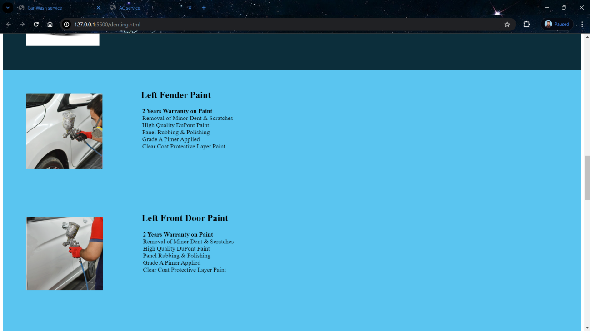

**Fig. 4.19 Denting And Penting Page**

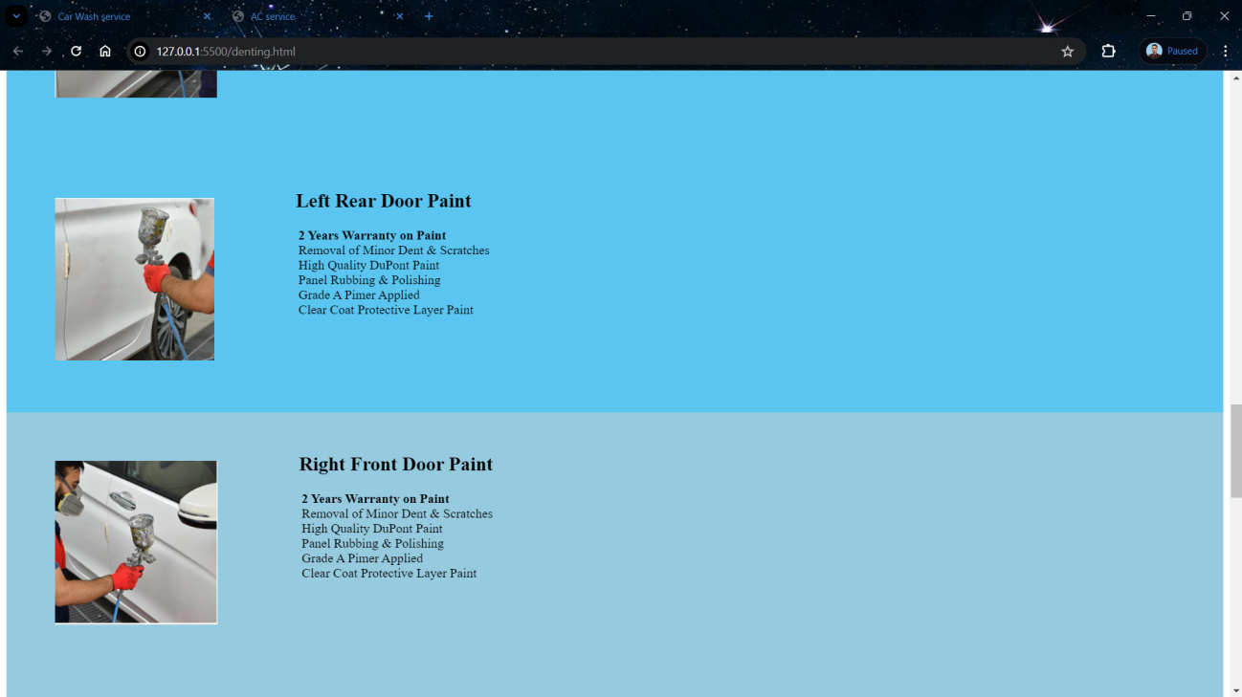

**Fig. 4.20 Denting And Penting Page**

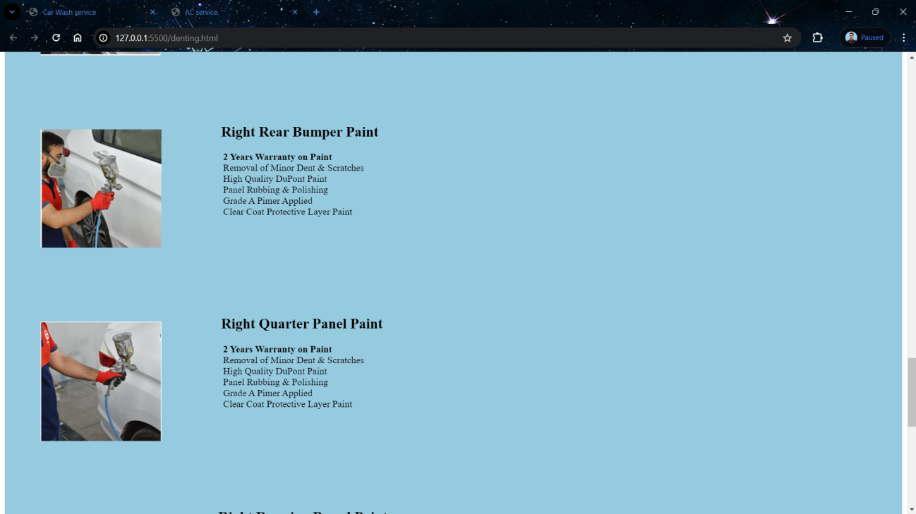

**Fig. 4.21 Denting And Penting Page**

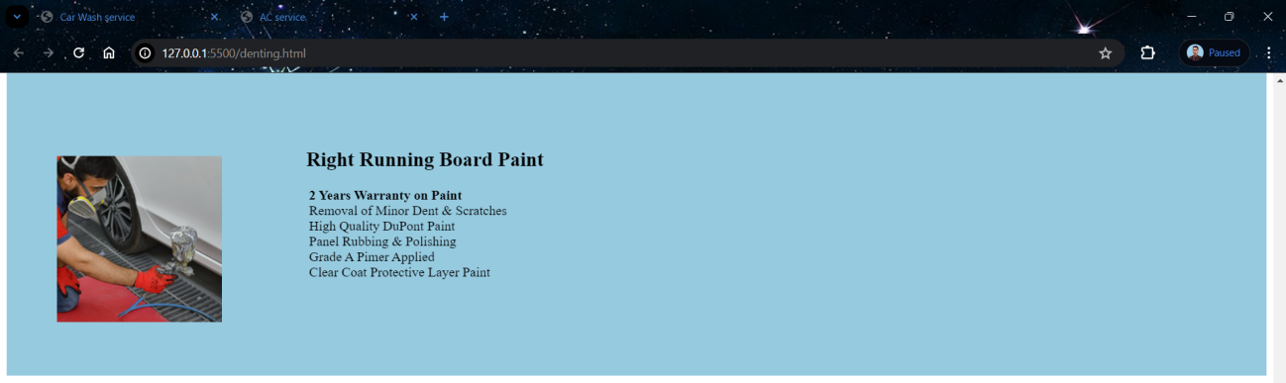

**Fig. 4.22 Denting And Penting Page**

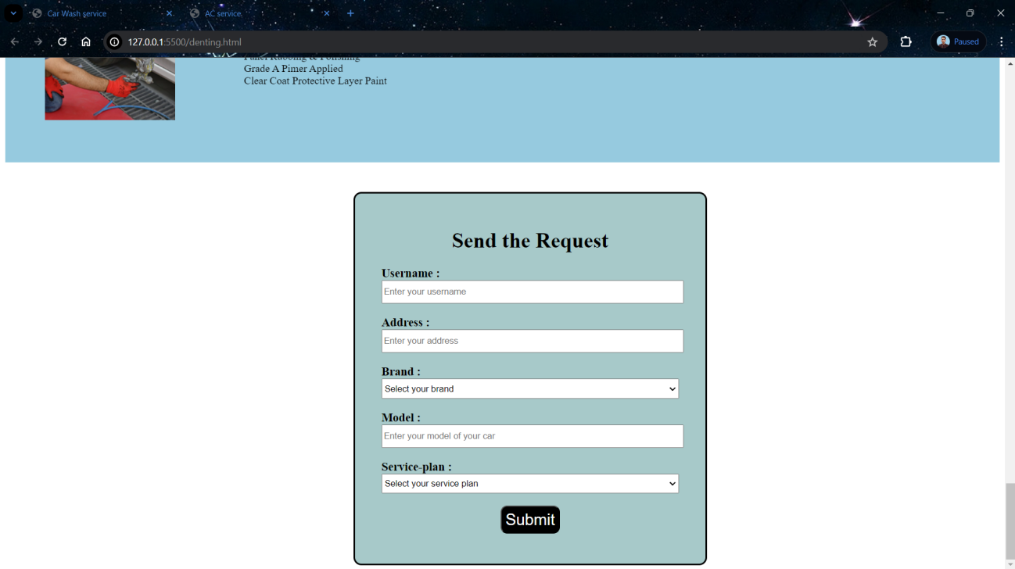

**Fig. 4.23 Denting And Penting Page**

**CHAPTER 5**

**TESTING**

Testing is a crucial phase in the development of the Vehicle Service and Wash Website to ensure that it meets quality standards, functions as intended, and provides a seamless user experience. Here's a comprehensive testing plan covering various aspects of the project:

**5.1 Functional Testing:**

**5.1.1 User Registration and Authentication:**

Verify that users can register accounts successfully. Test login functionality with valid and invalid credentials. Ensure password reset and account recovery mechanisms work as expected.

**5.1.2 Service Appointment Scheduling:**

Test the ability to schedule service appointments for different types of services (e.g., oil change, tire rotation). Verify that users can view available appointment slots and select preferred times.

**5.1.3 Car Wash Booking:**

Test the process of booking car wash services, including selecting wash packages and add-ons. Ensure accurate pricing calculation and payment processing.

**5.1.4 Service Provider Directory:**

Verify that users can search and browse service providers based on location and services offered. Test filtering options and sorting functionality.

**5.1.5 Appointment Management Dashboard:**

Test the dashboard functionality for service providers, including managing appointments, updating availability, and communicating with customers.

**5.2 Usability Testing:**

Evaluate the website's user interface for ease of navigation, clarity of instructions, and overall user experience. Gather feedback from users through surveys, interviews, or usability testing sessions. Identify any usability issues or pain points and make iterative improvements based on user feedback.

**5.3 Performance Testing:**

Test the website's performance under normal and peak load conditions to ensure scalability and reliability. Measure page load times, server response times, and overall system responsiveness. Identify and address any performance bottlenecks, such as slow database queries or inefficient code.

**5.4 Compatibility Testing:**

Test the website across different web browsers (e.g., Chrome, Firefox, Safari, Edge) and devices (e.g., desktops, laptops, tablets, smartphones). Ensure compatibility with various operating systems (e.g., Windows, macOS, iOS, Android) and screen resolutions.

**5.5 Security Testing:**

Conduct vulnerability assessments and penetration testing to identify potential security vulnerabilities. Test for common security threats, such as SQL injection, cross-site scripting (XSS), and authentication bypass. Implement encryption, secure authentication mechanisms, and data protection measures to safeguard user data.

**5.6 Accessibility Testing:**

Ensure that the website complies with accessibility standards, such as WCAG (Web Content Accessibility Guidelines). Test for accessibility features, including keyboard navigation, screen reader compatibility, and alternative text for images. Verify that users with disabilities can access and use the website effectively.

**5.7 Cross-Functional Testing:**

Test end-to-end workflows, such as registering a new user, scheduling a service appointment, and completing payment. Verify integration points with third-party APIs (e.g., Google Maps API, Stripe API) and external systems. Validate data consistency and accuracy across different modules and components.

**5.8 Regression Testing:**

Perform regression testing after each code change or new feature implementation to ensure that existing functionality remains intact.

**BIBLIOGRAPHY**

Here's a hypothetical bibliography for a Faculty Contribution Management System:

1. **Sommerville, I. (2016). "Software Engineering" (10th Edition). Pearson Education Limited.**

* This textbook provides a comprehensive overview of software engineering principles, methodologies, and best practices, which can be applied to the development of the website project.

1. **Pressman, R. S. (2014). "Software Engineering: A Practitioner's Approach" (8th Edition). McGraw-Hill Education.**

* This book offers practical insights into the software engineering process, including requirements analysis, design, development, testing, and maintenance, relevant to the development of the website project.

1. **McConnell, S. (2014). "Code Complete: A Practical Handbook of Software Construction" (2nd Edition). Microsoft Press.**

* "Code Complete" provides practical guidance and best practices for writing high-quality code, which is essential for developing a robust and maintainable website for vehicle service and wash.

1. **Fowler, M. (2002). "Patterns of Enterprise Application Architecture." Addison-Wesley Professional.**

* This book explores design patterns and architectural principles commonly used in enterprise application development, which can be valuable for designing the architecture of the website project.

1. **Gamma, E., Helm, R., Johnson, R., & Vlissides, J. (1994).**

* "Design Patterns: Elements of Reusable Object-Oriented Software." Addison-Wesley Professional.

**REFERENCE**

1. W3Schools.

https://www.w3schools.com/html/

1. Bootstrap Documentation.

https://getbootstrap.com/

1. Chatgpt

[https://chat.openai.com/](https://developer.mozilla.org/en-US/docs/Web/API/Document_Object_Model/Introduction)

1. Font Awesome Documentation.

[https://fontawesome.com/](https://fontawesome.com/v5.15/how-to-use/on-the-web/setup/getting-started)

1. Stack overflow

https://stackoverflow.com/